DNS Record

📄 What is a DNS Record?
# Source: Chatgpt (GPT-5-Mini) at [1/18/2026]
A DNS record is a piece of information stored in the Domain Name System (DNS) that tells computers how to handle requests for a domain — such as where to find a website, how to route email, or verify domain ownership.
🧠 Think of DNS records as the instructions or settings that define how your domain works on the internet.

📌 Common Types of DNS Records
# Source: Chatgpt (GPT-5-Mini) at [1/18/2026]
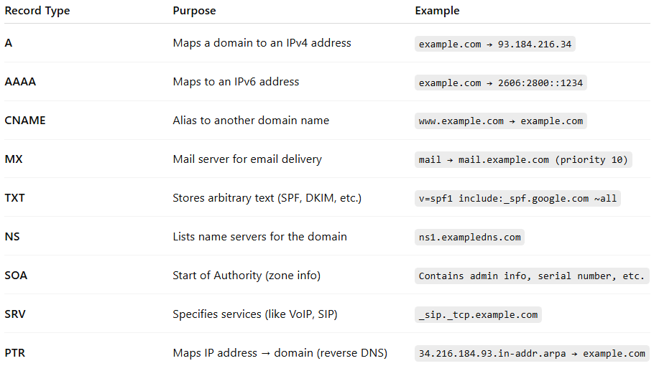
Record Type | Purpose | Example
A | Maps a domain to an IPv4 address | example.com → 93.184.216.34
AAAA | Maps to an IPv6 address | example.com → 2606:2800::1234
CNAME | Alias to another domain name | www.example.com → example.com
MX | Mail server for email delivery | mail → mail.example.com (priority 10)
TXT | Stores arbitrary text (SPF, DKIM, etc.) | v=spf1 include:_spf.google.com ~all
NS | Lists name servers for the domain | ns1.exampledns.com
SOA | Start of Authority (zone info) | Contains admin info, serial number, etc.
SRV | Specifies services (like VoIP, SIP) | _sip._tcp.example.com
PTR | Maps IP address → domain (reverse DNS) | 34.216.184.93.in-addr.arpa → example.com

📁 Where Are DNS Records Stored?
# Source: Chatgpt (GPT-5-Mini) at [1/18/2026]
DNS records are stored in zone files on authoritative DNS servers for a domain. These are managed by:
- Hosting providers
- Domain registrars
- DNS services like Cloudflare, Google DNS, AWS Route 53

🔍 Example Zone File (simplified)
# Source: Chatgpt (GPT-5-Mini) at [1/18/2026]
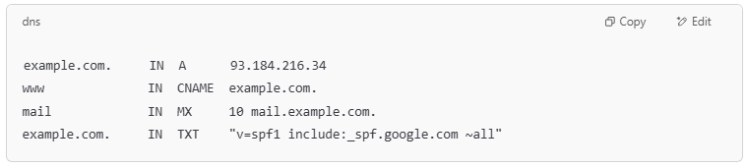
example.com. IN A 93.184.216.34
www IN CNAME example.com.
mail IN MX 10 mail.example.com.
example.com. IN TXT "v=spf1 include:_spf.google.com ~all"

✅ Summary
# Source: Chatgpt (GPT-5-Mini) at [1/18/2026]
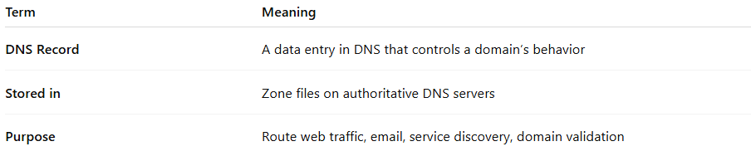
Term | Meaning
DNS Record | A data entry in DNS that controls a domain’s behavior
Stored in | Zone files on authoritative DNS servers
Purpose | Route web traffic, email, service discovery, domain validation

